Photograph to be glued in this box

Photograph Specification:
Photo should be straight looking, centered with a smile, and skin tone should be natural. The eyes must be open and no hair obscuring the face. As well as the photo must have plain light background.)

Application Number

Assessment Date

Cabin Crew Declaration Form

- Candidate Details (Kindly fill below required information)

Personal Information
Full Name (As per passport) |  | Date Of Birth (DD/MM/YY)
Nationality |  | Passport Number
Passport Expiry Date |  | Country of Residence
Height (In cm) |  | Weight (In kg)
Language(s) Spoken |  | UAE Visa Type – If Applicable (Tourist/Employment/Residence)
Contact Number |  | Email Address

General Information
Current Place of Work
Current Position / Designation
Any previous experience in customer service? (If yes, please list the company and years of Experience.)
Any previous cabin crew experience? (If yes, please list the airline and years of Experience.)
Are you confident in water and able to swim with the aid of a flotation device?

Medical History
Have you ever undergone any surgical operation and/or been admitted to hospital for a serious illness? (If yes, please provide further details)
Do you have any history of skin allergy? (If yes, please provide further details)
Do you suffer from any of the following? Recurrent headaches/ migraines/ recurrent backache/ rheumatism. (If yes, please provide further details)
Have you ever suffered from an Industrial illness or work place accident? (If yes, please provide further details)
Are you currently receiving any medication prescribed by a doctor? (If yes, please provide further details)
Would you like to declare any other medical conditions or health issues?

Grooming Information
Do you have any tattoos? (If yes please indicate the size and location in the below figure)
Do you have any scars? (If yes please indicate the size and location in the below figure)

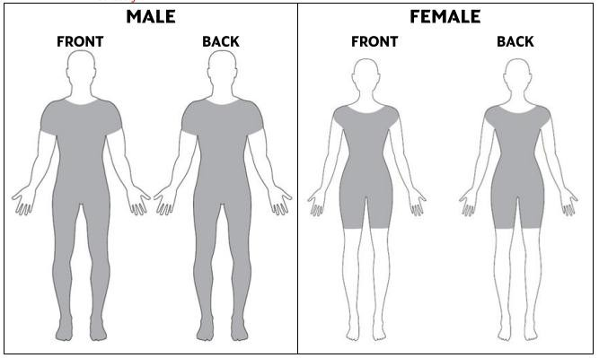

- Candidate Declaration
REFERENCE DISCLAIMER (Please read the attached carefully. Signing the Cabin Crew Declaration Form will be considered as an acceptance of the below disclaimer)
I, ___________________________________, hereby authorize Air Arabia or any duly accredited representative of the Company bearing this release to obtain any information from employers, criminal justice agencies, or individuals, relating to my activities. This information may include, but is not limited to, academic achievement, performance, attendance, personal data, disciplinary, arrest, and conviction records. I hereby direct you to release such information upon request of the bearer. I understand that the information released is for official use by Air Arabia and may be disclosed to such third parties as necessary in the fulfillment of official responsibilities.
I acknowledge that this information is governed by relevant data privacy regulations prevailing at the time. I hereby release any individual from Air Arabia or its third parties, including record custodians, from any and all liability for damages of whatever kind or nature which may at any time result to me on account of compliance, or any attempts to comply, with this authorization.

Signature: Date:

